|  |  |  |  |  |
| --- | --- | --- | --- | --- |
| **Class** | **SE1843** | **Group 2** | **01** | **Contribution** |
| **#** | **Student ID** | **Student Name** | **Task** | **(0-100%)** |
| 1 | SE170345 | Phùng Hữu Thành | Write code, build tinker card, testing | 100% |
| 2 | SE170333 | Lê Văn Huy Hoàng | Draw block diagram, testing | 100% |
| 3 | SE170415 | Lê Nhật Quang | Write report, support code | 100% |
| 4 | SE172855 | Phan Thanh Long Châu | Attach real circuit, testing | 100% |
| 5 |  |  |  |  |

**IOT 102: PROGRESS TEST 1**

**DO NOT COPY**

**Components**: Arduino Uno

Input: Ultrasonic rangefinder, Keypad 4x4, photoresistor,…

Output: Servo motor, LCD, LED, buzzer,…

**Task**: Design a security door.

**Description**:

* Photoresistor is used to turn on an LED for the user to input a password from the keypad when it is dark.
* Ultrasonic range finder is used to detect the user that is in front of the door (distance is less than the threshold). The LCD screen activates when a user is detected, enabling password input.
* The system can store up to 3 passwords in EEPROM. Each password is coressponding to one user name, and it can have any length, and the system verifies it once a "#" character is detected. Successful verification occurs if the entered string contains the password. For example, if the password is "12345," the input "561234589#" would be accepted.
* Upon entering the correct password, LCD displays a welcome messge, and a servo motor is activated to open the door. The door automatically closes after a specified delay (for example 3 seconds).
* If an incorrect password is entered three times consecutively, the keypad locks, and a buzzer is on for 3 seconds.
* Implement a password change functionality that allows users to change passwords and the new password is stored in EEPROM.

1. **Block diagram: A diagram of a computer

   Description automatically generated**
2. **Picture of your design:**

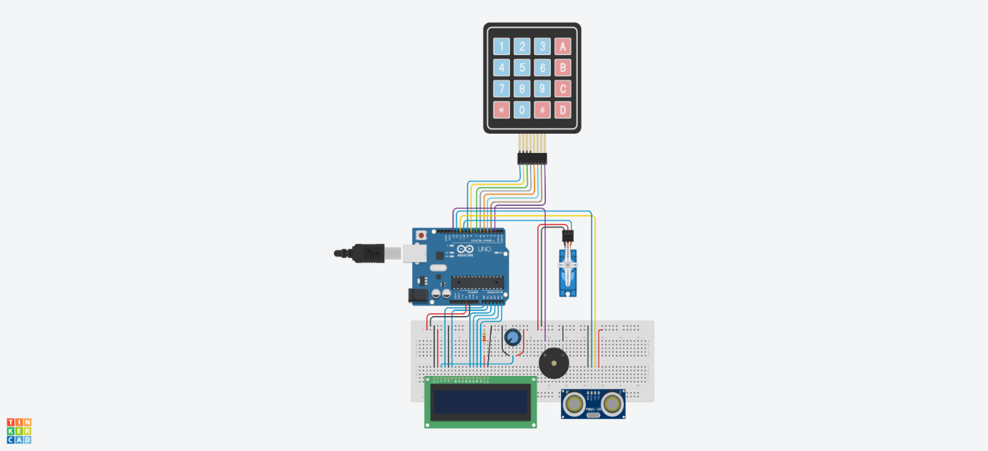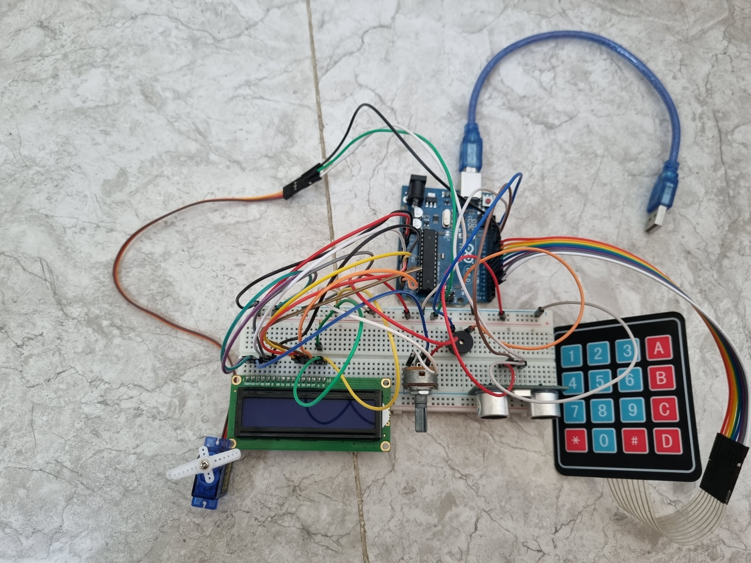

1. **Flowchart (algorithm)**

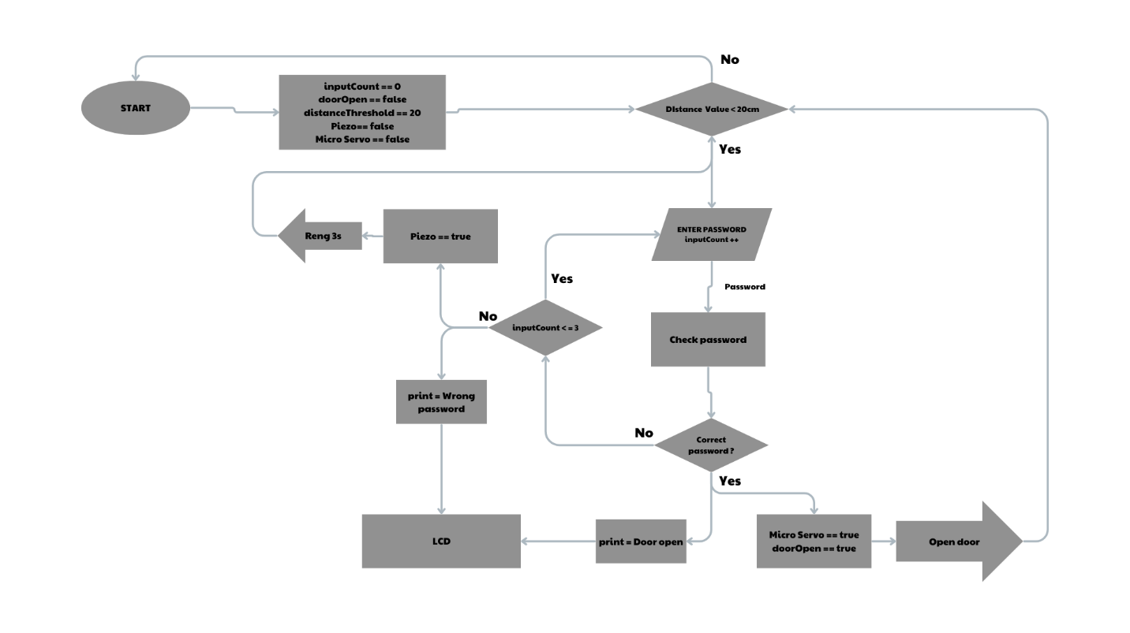

1. **Code:**

#include <Keypad.h>

#include <EEPROM.h>

#include <LiquidCrystal.h>

#include <Servo.h>

const int rs = A0, en = A1, d4 = A2, d5 = A3, d6 = A4, d7 = A5;

LiquidCrystal lcd(rs, en, d4, d5, d6, d7);

Servo myservo;

const byte ROWS = 4;

const byte COLS = 4;

char hexaKeys[ROWS][COLS] = {

{'1', '2', '3', 'A'},

{'4', '5', '6', 'B'},

{'7', '8', '9', 'C'},

{'*', '0', '#', 'D'}};

byte rowPins[ROWS] = {9, 8, 7, 6};

byte colPins[COLS] = {5, 4, 3, 2};

Keypad customKeypad = Keypad(makeKeymap(hexaKeys), rowPins, colPins, ROWS, COLS);

const int motorPin = 10;

const int buzzerPin = 13;

const int TRIG_PIN = 11;

const int ECHO_PIN = 12;

int inputCount = 0;

int timeLock = 0;

bool doorOpen = false;

const int distanceThreshold = 20; // 20cm

String D2003 = "1234";

String D2004 = "5678";

String D2005 = "1357";

void setup()

{

Serial.begin(9600);

lcd.begin(16, 2);

myservo.attach(motorPin);

myservo.write(0);

pinMode(TRIG_PIN, OUTPUT);

pinMode(ECHO_PIN, INPUT);

if (readStringFromEEPROM(0) == ""){

writeStringToEEPROM(0, D2003);

} else {

D2003 = readStringFromEEPROM(0);

}

if (readStringFromEEPROM(5) == ""){

writeStringToEEPROM(5, D2004);

} else {

D2004 = readStringFromEEPROM(5);

}

if (readStringFromEEPROM(10) == ""){

writeStringToEEPROM(10, D2005);

} else {

D2005 = readStringFromEEPROM(10);

}

}

void writeStringToEEPROM(int addrOffset, String strToWrite)

{

byte len = strToWrite.length();

EEPROM.write(addrOffset, len);

for (int i = 0; i < len; i++)

{

EEPROM.write(addrOffset + 1 + i, strToWrite[i]);

}

}

String readStringFromEEPROM(int addrOffset)

{

int newStrLen = EEPROM.read(addrOffset);

char data[newStrLen + 1];

for (int i = 0; i < newStrLen; i++)

{

data[i] = EEPROM.read(addrOffset + 1 + i);

}

data[newStrLen] = '\0';

return String(data);

}

boolean verifyPassword(String enteredPassword, String password)

{

return enteredPassword.indexOf(password) != -1;

}

void enterDisplay()

{

lcd.setCursor(0, 0);

lcd.print("Enter password :");

Serial.println("Enter password :");

}

String getPasswordInput(boolean changePass)

{

lcd.clear();

unsigned long startTime = millis();

unsigned long timeout = 20000;

if (changePass == false)

{

lcd.print("Enter password :");

}

else

{

lcd.print("New password: ");

}

String lcdPass = "";

String input = "";

char key;

while (true)

{

key = customKeypad.getKey();

if (key)

{

if (key == '#')

{

break;

}

else if (key == 'C')

{

boolean success = changePassword();

if (success)

{

return "change";

}

else

{

return "not change";

}

}

else if (key == 'D')

{

lcdPass = "";

input = "";

lcd.clear();

lcd.print("Enter password :");

}

else if (key == 'B')

{

writeStringToEEPROM(0, "1234");

writeStringToEEPROM(5, "5678");

writeStringToEEPROM(10, "1357");

}

else

{

lcd.setCursor(0, 1);

lcdPass += "*";

lcd.print(lcdPass);

input += key;

}

}

if (millis() - startTime > timeout)

{

return "Timeout! No input.";

}

}

return input;

}

boolean changePassword()

{

lcd.clear();

lcd.print("Before password:");

String lcdPass = "";

String input = "";

char key;

while (true)

{

key = customKeypad.getKey();

if (key)

{

if (key == '#')

{

break;

}

else

{

lcd.setCursor(0, 1);

lcdPass += "*";

lcd.print(lcdPass);

input += key;

}

}

}

String passEEPROM = readStringFromEEPROM(0);

String newPass = "";

if (input == D2003 || input == passEEPROM)

{

newPass = getPasswordInput(true);

D2003 = newPass;

writeStringToEEPROM(0, D2003);

return true;

}

else if (input == D2004)

{

newPass = getPasswordInput(true);

D2004 = newPass;

writeStringToEEPROM(5, D2004);

return true;

}

else if (input == D2005)

{

newPass = getPasswordInput(true);

D2005 = newPass;

writeStringToEEPROM(10, D2005);

return true;

}

else

{

lcd.clear();

lcd.print("Invalid password");

delay(2000);

}

return false;

}

void incorrectPass()

{

lcd.print("Lock surcurity!");

tone(buzzerPin, 1000, 3000);

delay(3000);

noTone(buzzerPin);

lcd.setCursor(0, 0);

}

void openDoor()

{

myservo.write(90);

doorOpen = true;

}

void closeDoor()

{

myservo.write(0);

doorOpen = false;

}

void lockKeypad() {

lcd.clear();

lcd.print("Keypad locked!");

String countDown = "";

tone(buzzerPin, 1000, 3000);

lcd.setCursor(0, 1);

timeLock += 3000;

for (int i = timeLock / 1000; i > 0; i--) {

lcd.setCursor(0, 1);

if (i < 10) {

lcd.print("0");

}

lcd.print(i);

delay(1000);

}

lcd.clear();

lcd.print("Unlocking...");

delay(2000);

}

void loop()

{

digitalWrite(TRIG_PIN, LOW);

delayMicroseconds(2);

digitalWrite(TRIG_PIN, HIGH);

delayMicroseconds(10);

digitalWrite(TRIG_PIN, LOW);

const long duration = pulseIn(ECHO_PIN, HIGH);

int distance = duration / 29 / 2;

if (distance < distanceThreshold && !doorOpen)

{

String enteredPassword = getPasswordInput(false);

String passEEPROM1 = readStringFromEEPROM(0);

String passEEPROM2 = readStringFromEEPROM(5);

String passEEPROM3 = readStringFromEEPROM(10);

if (verifyPassword(enteredPassword, passEEPROM1) ||

verifyPassword(enteredPassword, passEEPROM2) ||

verifyPassword(enteredPassword, passEEPROM3))

{

lcd.clear();

lcd.print("Door Opened!");

inputCount = 0;

openDoor();

delay(5000);

closeDoor();

}

else if (enteredPassword == "change")

{

lcd.clear();

lcd.print("Change ok!");

delay(3000);

}

else if (enteredPassword == "not change")

{

lcd.clear();

lcd.print("Change not ok!");

delay(3000);

}

else if (enteredPassword == "Timeout! No input.") {

lcd.clear();

lcd.print("Timeout!");

delay(2000);

}

else

{

inputCount++;

if (inputCount >= 3)

{

lockKeypad();

}

else

{

lcd.clear();

lcd.print("Wrong password!");

delay(2000);

lcd.clear();

}

}

}

else if (distance > distanceThreshold)

{

lcd.clear();

}

delay(100);

}

**5.Tinkercad link:**

https://www.tinkercad.com/things/5jj8NZMbReN-progress-test-1-group-2-se1843/editel?returnTo=%2Fdashboard%3Fcollection%3Ddesigns&sharecode=8ezzGNiSzaFermpCFb3ryC1prQHTSrABB-1tDtvhlvA

**6.Video clip (Google Drive):**

https://drive.google.com/drive/folders/1MTwjtybJjs-3tOnzbSIUTG4tE034CI18?usp=drive_link